DCC-GARCH correlation: NZDUSD and USDCAD
Method 09 / GARCH(1,1) + Engle DCC / Alpari D1 full available history

Study setup
Logical pair: NZDUSD , USDCAD
Broker symbols: NZDUSD_i , USDCAD_i
Snapshot: 2026-11-03_majors_alpari_D1
Timeframe: D1
Matched return window: 1999-01-05 to 2026-11-02 (UTC bar dates)
Matched return count n: 7190
Dropped unfinished last bar dated 2026-11-03 UTC after a tick-volume check against the prior complete day.
NZDUSD GARCH(1,1): mu=0.000000, omega=0.004961, alpha=0.040841, beta=0.950110
USDCAD GARCH(1,1): mu=-0.000004, omega=0.001257, alpha=0.043703, beta=0.951156
DCC: a=0.015037, b=0.983083, a+b=0.998120
Burn-in ignored in path summaries and chart: first 60 updates
Complete matched rows (Excel): NZDUSD-USDCAD_DCC_D1.xlsx
Complete matched rows (HTML table): NZDUSD-USDCAD_DCC_D1_data.html

Method carried forward
DCC-GARCH first fits a constant-mean GARCH(1,1) on each matched daily log return of close, ln(close_t / close_t-1), then updates Engle (2002) dynamic conditional correlation on the standardised shocks z = residual / conditional sigma. Quotes are not inverted. Correlation targeting sets Q_bar to the sample correlation of z; a and b are estimated by maximising the bivariate Gaussian DCC likelihood with a >= 0, b >= 0, and a + b < 1. Path summaries ignore the first 60 updates. The headline is rho on the last day. Same-sample Pearson r on log returns is a side check only. A high |rho| does not prove cause, lead-lag, or a trading signal.

Results
Latest DCC rho: -0.508162
Post-burn-in path (n=7130): mean=-0.542292, median=-0.558174, min=-0.815884, max=-0.093664, std=0.134957
Share of post-burn-in days with |rho| >= 0.4: 83.11%; |rho| >= 0.7: 10.48%
Same-sample Pearson r: -0.587831
Latest rho minus r: 0.079669

Conclusion
Over 7190 matched daily log-return rows for NZDUSD and USDCAD (broker quote directions unchanged), latest DCC rho is -0.5082 (negative, moderate conditional linear link in this sample) with fitted a=0.0150, b=0.9831 (a+b=0.9981). After a 60-day burn-in, path mean is -0.5423 and std is 0.1350. Same-sample Pearson r is -0.5878 (latest rho minus r = 0.0797). This does not establish cause, lead-lag, or a lasting trading rule.

Charts
Daily closes

Daily log returns
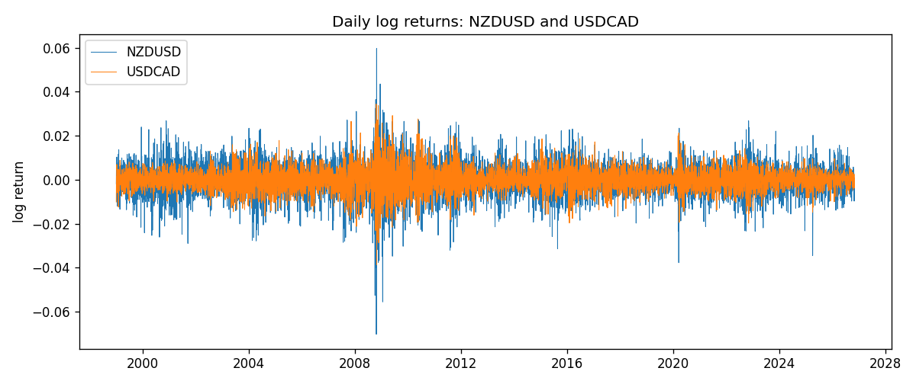
DCC rho path with Pearson r reference
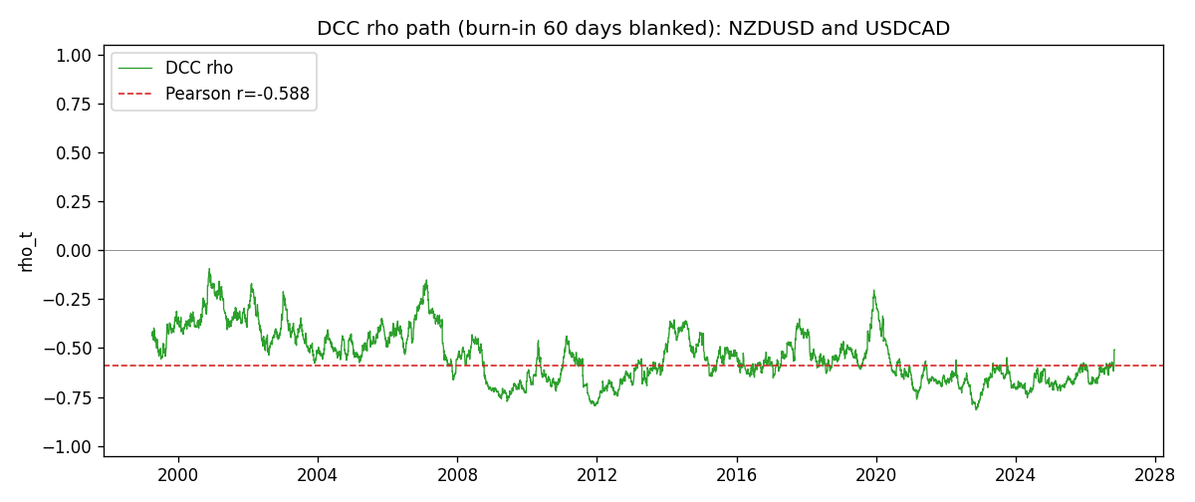

Data report
Every matched row that entered the DCC recursion is stored in the sibling Excel workbook named NZDUSD-USDCAD_DCC_D1.xlsx. Embedding all rows as a Word table is impractical at this length; the Word file holds the column list, column summaries, and the first and last 15 matched rows.
Columns: time, NZDUSD_open, USDCAD_open, NZDUSD_high, USDCAD_high, NZDUSD_low, USDCAD_low, NZDUSD_close, USDCAD_close, NZDUSD_tick_volume, USDCAD_tick_volume, NZDUSD_spread, USDCAD_spread, NZDUSD_real_volume, USDCAD_real_volume, NZDUSD_log_return, USDCAD_log_return, NZDUSD_sigma, USDCAD_sigma, NZDUSD_z, USDCAD_z, q11, q22, q12, rho_t
Column summaries (matched calculation rows)
column | count | mean | std | min | 25% | 50% | 75% | max
NZDUSD_open | 7190 | 0.6563919 | 0.10821436 | 0.3913 | 0.5912925 | 0.6684 | 0.7249075 | 0.88218
USDCAD_open | 7190 | 1.2668559 | 0.16897553 | 0.9168 | 1.118445 | 1.298545 | 1.37213 | 1.6183
NZDUSD_high | 7190 | 0.66030697 | 0.10871111 | 0.3961 | 0.5947025 | 0.67202 | 0.72936 | 0.88421
USDCAD_high | 7190 | 1.2717549 | 0.16892987 | 0.9336 | 1.122975 | 1.30394 | 1.37655 | 1.619
NZDUSD_low | 7190 | 0.65270307 | 0.10781082 | 0.3897 | 0.5880525 | 0.664185 | 0.720965 | 0.87988
USDCAD_low | 7190 | 1.2623003 | 0.16901312 | 0.9056 | 1.114125 | 1.293585 | 1.36785 | 1.6102
NZDUSD_close | 7190 | 0.65646372 | 0.10821182 | 0.3907 | 0.5915625 | 0.66842 | 0.725015 | 0.8822
USDCAD_close | 7190 | 1.266877 | 0.16895077 | 0.916 | 1.118165 | 1.298615 | 1.372425 | 1.6137
NZDUSD_tick_volume | 7190 | 68672.777 | 123109.57 | 16 | 5561.25 | 33864.5 | 58508 | 1127682
USDCAD_tick_volume | 7190 | 80995.8 | 147287.89 | 37 | 5534 | 40938 | 71622.5 | 1410818
NZDUSD_spread | 7190 | 30.299444 | 25.655426 | 0 | 9 | 17 | 50 | 80
USDCAD_spread | 7190 | 23.448679 | 18.267866 | 0 | 9 | 17 | 40 | 60
NZDUSD_real_volume | 7190 | 1.6692087e+10 | 8.4955308e+10 | 0 | 0 | 0 | 0 | 2.705649e+12
USDCAD_real_volume | 7190 | 1.8371592e+10 | 9.6675129e+10 | 0 | 0 | 0 | 0 | 2.5751613e+12
NZDUSD_log_return | 7190 | 6.02e-06 | 0.00764513 | -0.07027433 | -0.00425619 | 0.00022347 | 0.00457637 | 0.05966839
USDCAD_log_return | 7190 | -9.38e-06 | 0.0051433 | -0.03859748 | -0.00283202 | 5.381e-05 | 0.00272817 | 0.03436319
NZDUSD_sigma | 7190 | 0.00728682 | 0.0021722 | 0.00438984 | 0.00595468 | 0.00669641 | 0.00804191 | 0.02526221
USDCAD_sigma | 7190 | 0.00479404 | 0.00181451 | 0.0025086 | 0.00365477 | 0.00435556 | 0.00535435 | 0.0185305
NZDUSD_z | 7190 | -0.00229057 | 1.0000717 | -5.6191746 | -0.63013359 | 0.03284573 | 0.64644398 | 4.2840273
USDCAD_z | 7190 | 0.00188001 | 1.0000915 | -4.0722206 | -0.6275067 | 0.0112032 | 0.61255652 | 6.4164912
q11 | 7190 | 1.0019411 | 0.14367496 | 0.68399326 | 0.90336913 | 0.97802476 | 1.0748853 | 1.9253543
q22 | 7190 | 1.0016759 | 0.13849292 | 0.69488293 | 0.91084499 | 0.98536038 | 1.0681831 | 1.7733242
q12 | 7190 | -0.54447923 | 0.16505175 | -1.2201454 | -0.64490684 | -0.5442761 | -0.43194429 | -0.09693171
rho_t | 7190 | -0.54157222 | 0.13468339 | -0.81588386 | -0.6494088 | -0.55652192 | -0.44631869 | -0.093664
First 15 matched rows (selected columns)
time | NZDUSD_log_return | USDCAD_log_return | NZDUSD_sigma | USDCAD_sigma | NZDUSD_z | USDCAD_z | q11 | q22 | q12 | rho_t
1999-01-05 | -0.0018597736 | -0.010131666 | 0.0058824673 | 0.0045253618 | -0.316157 | -2.238089 | 1 | 1 | -0.54327233 | -0.54327233
1999-01-06 | 0.0020455609 | -0.0003306769 | 0.0057891679 | 0.0049078871 | 0.35334117 | -0.066662798 | 0.98646588 | 1.0602846 | -0.52446295 | -0.51281716
1999-01-07 | 0.0062963171 | 0.0015202092 | 0.0057017074 | 0.0048001245 | 1.1042846 | 0.31743188 | 0.97353507 | 1.0442945 | -0.51696607 | -0.5127135
1999-01-08 | -0.00055396548 | -0.0020495197 | 0.0057448072 | 0.0047056265 | -0.096430572 | -0.43480211 | 0.97728259 | 1.0300232 | -0.50397076 | -0.50230993
1999-01-11 | 0.010290425 | -0.0035137769 | 0.0056449075 | 0.0046227703 | 1.8229556 | -0.75934414 | 0.96276956 | 1.0173209 | -0.49583586 | -0.50101158
1999-01-12 | -0.0053157489 | 0.0066194721 | 0.005924203 | 0.0045815284 | -0.89729513 | 1.4455821 | 0.99833321 | 1.0106612 | -0.50928425 | -0.50701369
1999-01-13 | -0.0099742238 | 0.0045420214 | 0.0059156948 | 0.0046912486 | -1.6860629 | 0.96893711 | 0.99543124 | 1.026867 | -0.52119485 | -0.51551035
1999-01-14 | -0.00018564931 | 0.0069376546 | 0.0061488847 | 0.0046863132 | -0.03019391 | 1.4811554 | 1.0232191 | 1.0254928 | -0.5379651 | -0.5251743
1999-01-15 | -0.00074294208 | -0.0056905671 | 0.0060349033 | 0.0048083391 | -0.12310912 | -1.1827501 | 1.0078029 | 1.0430132 | -0.53055809 | -0.51748794
1999-01-18 | -0.0018597736 | 0.00098344542 | 0.0059263608 | 0.0048507735 | -0.31381539 | 0.20346215 | 0.99286163 | 1.0482839 | -0.52041438 | -0.51011192
1999-01-19 | 0.0018597736 | 0.002748513 | 0.0058315467 | 0.0047485744 | 0.31891438 | 0.57954581 | 0.97942609 | 1.0330524 | -0.51359191 | -0.51058866
1999-01-20 | 0.0040793678 | -0.0059646885 | 0.0057400119 | 0.0046801977 | 0.71068812 | -1.2737037 | 0.96626635 | 1.0225067 | -0.50314548 | -0.50618826
1999-01-21 | 0.0040627941 | -0.0042823796 | 0.0056991024 | 0.0047447932 | 0.71288148 | -0.90180457 | 0.95939479 | 1.0314839 | -0.50926675 | -0.5119357
1999-01-22 | -0.012051689 | 0.0025057712 | 0.0056594731 | 0.0047264436 | -2.1294737 | 0.53090121 | 0.95268642 | 1.0281431 | -0.51133983 | -0.51666357
1999-01-25 | -0.0035504102 | 0.00085579808 | 0.0060712239 | 0.0046528473 | -0.58479472 | 0.18468293 | 1.006638 | 1.0168682 | -0.52071086 | -0.51466856
Last 15 matched rows (selected columns)
time | NZDUSD_log_return | USDCAD_log_return | NZDUSD_sigma | USDCAD_sigma | NZDUSD_z | USDCAD_z | q11 | q22 | q12 | rho_t
2026-10-13 | 0.0047326165 | -0.0046395653 | 0.0049246734 | 0.0028854469 | 0.96099915 | -1.6067049 | 0.77304686 | 0.81929738 | -0.46191815 | -0.58041861
2026-10-14 | -0.0037306483 | 0.0015184751 | 0.0049450327 | 0.0029973543 | -0.75442531 | 0.50777396 | 0.7757361 | 0.84613555 | -0.47834312 | -0.59042204
2026-10-15 | 0.0047634855 | -0.0036101503 | 0.004929294 | 0.0029617948 | 0.96636068 | -1.2177234 | 0.77305126 | 0.83757837 | -0.47703264 | -0.59283143
2026-10-16 | 0.0057501001 | -0.0034322068 | 0.0049506141 | 0.0030063141 | 1.1614904 | -1.1405007 | 0.77589582 | 0.8475867 | -0.48767905 | -0.60136801
2026-10-19 | 0.0018917133 | -0.0018835331 | 0.0050132178 | 0.0030390676 | 0.37734321 | -0.61862056 | 0.78493579 | 0.85468733 | -0.50036966 | -0.6109002
2026-10-20 | 0.0037199341 | -0.0037066008 | 0.004951848 | 0.0030108077 | 0.75121946 | -1.2299349 | 0.77567792 | 0.84786298 | -0.49643632 | -0.61215302
2026-10-21 | 0.0030923331 | -0.00084691787 | 0.0049354592 | 0.0030573146 | 0.62655235 | -0.27586774 | 0.77292148 | 0.85814678 | -0.50295296 | -0.61755961
2026-10-22 | -0.0033035227 | -0.0026307268 | 0.0049020597 | 0.0030078879 | -0.67390697 | -0.87344459 | 0.76762884 | 0.84665368 | -0.49806486 | -0.61781345
2026-10-23 | 0.0030929853 | 2.85545e-05 | 0.0048757753 | 0.0030054638 | 0.63435567 | 0.010666544 | 0.76335177 | 0.84568257 | -0.48180917 | -0.59966543
2026-10-26 | -0.0028993932 | 5.7106554e-05 | 0.0048449969 | 0.0029525143 | -0.59843231 | 0.020528255 | 0.75836898 | 0.83325766 | -0.47457791 | -0.59700446
2026-10-27 | -0.00026399852 | 0.0025379458 | 0.0048106505 | 0.0029012745 | -0.054879914 | 0.87597682 | 0.75280455 | 0.82104757 | -0.46775545 | -0.59496795
2026-10-28 | -0.0097283914 | -0.0038379274 | 0.0047420227 | 0.0029007262 | -2.0515298 | -1.3218841 | 0.74199441 | 0.82057624 | -0.46158656 | -0.5915526
2026-10-29 | 0.00062190714 | -0.00011436495 | 0.0050721156 | 0.0029616665 | 0.12261108 | -0.037432149 | 0.79460986 | 0.83484993 | -0.4140201 | -0.50832356
2026-10-30 | 0.00019537668 | -0.0010298736 | 0.004995479 | 0.0029101982 | 0.039108785 | -0.3526805 | 0.78327329 | 0.82262764 | -0.40810636 | -0.50841114
2026-11-02 | -0.0025962955 | 0.00061519094 | 0.0049201139 | 0.0028683274 | -0.52769207 | 0.21569866 | 0.77192543 | 0.81246141 | -0.40243106 | -0.50816231

